San Antonio By Night
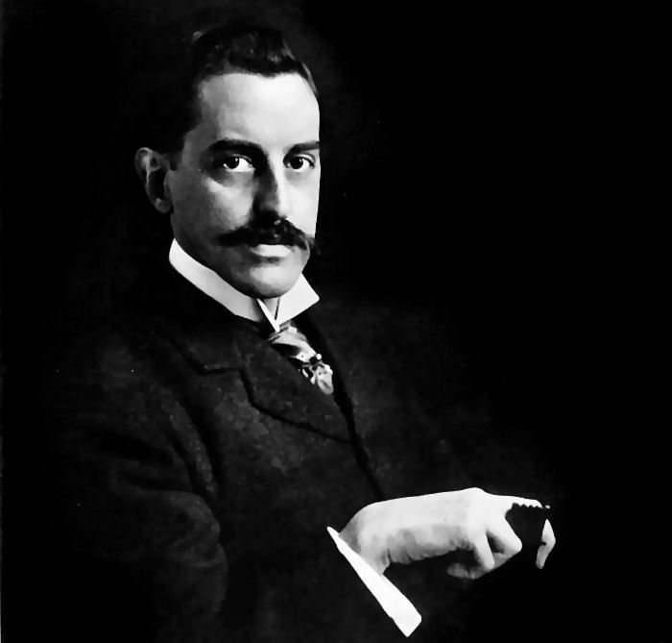Sybrant Vanderbilt - 6th Gen. Ventrue PRINCE
High Society | Judge | Police Chief | City Planner | Media Mogul | Valet
Molly Herekamp | Gary Edwards | Jesus Martinez | Ted Selker | Tally Nunoz | Cecilia Davis

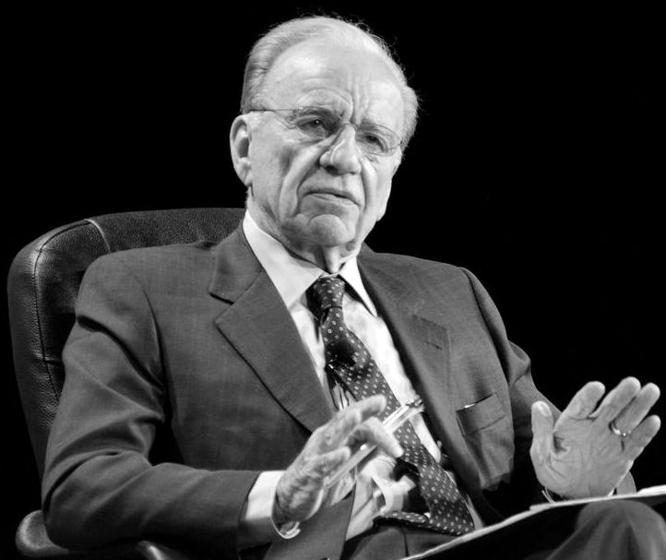Allen Stanford - 7th Gen. Ventrue SENESCHAL
High Society | Lawyer | Sherriff | Industrialist
Avery Fitzhugh | Hayne Aydelott | John McNeill | Bruce Stronghold

Sutara Sing - 7th Gen. Tremere SHERRIFF / PRIMOGEN
City Council | Occultretailer | ResearchChair | Valet
Andrew Middleton | Quelli Ladon | Gene Locke | Chen Howe

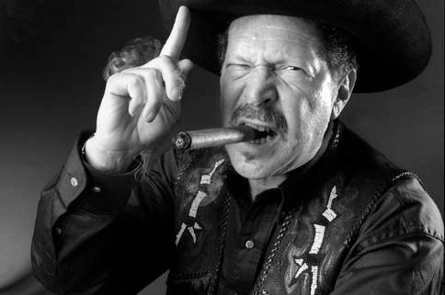Harold Simmons Sr.- 7th Gen. Ventrue PRIMOGEN
Mayor | Newspaper Ed. | Texas Ranger
Jim Rhodes | Christofer Fahr | Andrew Patton

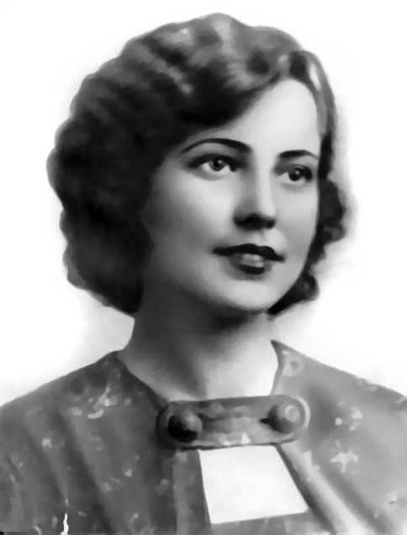Anastasia Romanov - 6th Gen. Toreador PRIMOGEN
Valet | Secretary
Walter Halberstram | Suzanne Halberstram

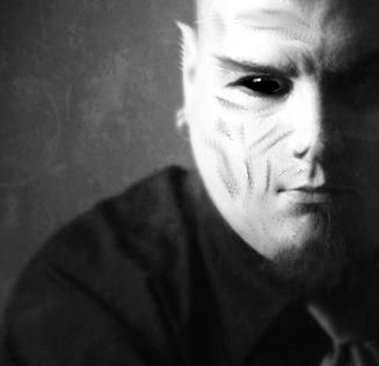Ahab Cromwell - 9th Gen. Nosferatu PRIMOGEN
Gang Leader | Union Boss | Dockmaster | Drug Dealer
Fabien Pree | Manny Venzuela | Thomas Hernandez | Jamaar Thompson

Alera - 8th Gen Malkavian PRIMOGEN
Chief of Med. | Military Base  Commander | Univerity Archivist | Psychiatrist | Police Internal Affairs | Preacher & Serial killer
Addison Wells | Robert Sutterfield | Daniel Simmons | Elissa Hayes | Elliot Hill | Dylan Carpenter

Rebecca Lancaster - 8th Gen. Toreador KEEPER
Valet
Moira Ledbetter

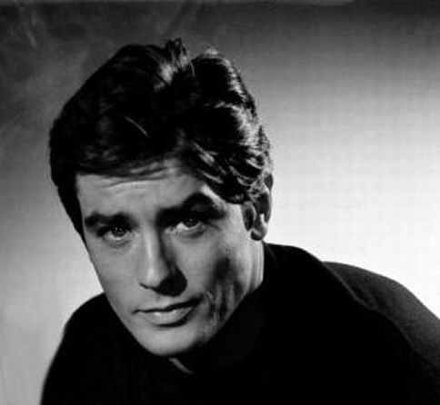Ariel d'Angoulême - 9th Gen. Ventrue CHIEF HARPY
Nightclub Owner | MagazineEditor | SororityPresident | Talent/modelingAgent | Paparazzi | Valet
La’Stacia | Christina Hill | Mandy O’Toole | Navia Moore | Sean Brewer | Anton Gerbracht

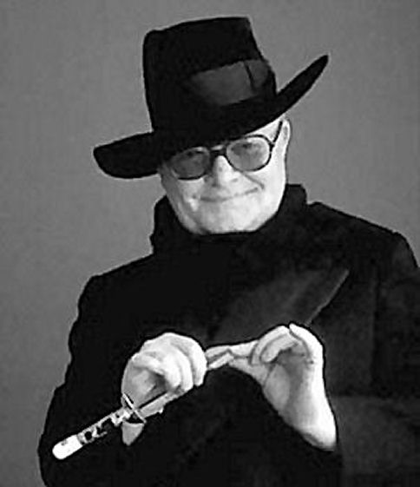 Louis Darling - 10th Gen.Toreador HAPRY
Valet | Art Dealer | Museum Curator
Robert “Bobby” Potter | Samantha Browning | Georgianna Lester

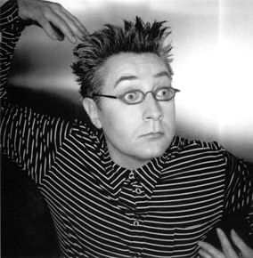Michael Arnauld - 8th Gen.Toreador HARPY
Valet | Artist | Art Critic
Ivan Thatcher | Chambliss Peterson | Cecilia Martinez

Tiberius Astor - 8th Gen. Ventrue
Sophie Pope - 9th Gen. Ventrue
Accountant | District Attorney
Jason Harrison | Ryan Cooper

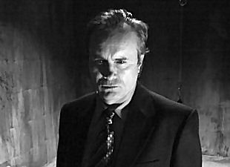Randall Garrison - 9th Gen. Tremere

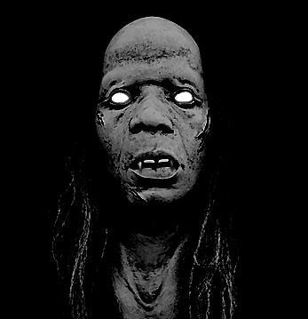Gardenia St. Claire - 9th Gen. Nosferatu
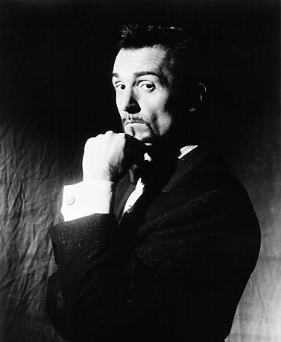Mark-Anthony Giovanni - 9th Gen. Giovanni
Lawyer | Crooked Cop | Thug | Thug
Mariel O’Neil | Steven Branch | Henri Poindexter | Daron Wells

Thomas Aquinas “Tommy” Giovanni - 9th Gen. Giovanni
Contract Killer | Drug Dealer | Pimp | Thug
Victoria “Vikki” Bladovich | Hernan Gutierrez | Markevien Clark | Ramone Bullworth

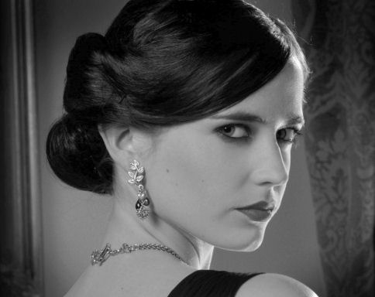Millicent Blanc - 10th Gen. Tremere
New Age Guru | Psychiatrist | Librarian
Usiname Siam | Helen Daniel | Connie Blevins

Sara Miller - 11th Gen. Settite
Pimp | Drug Dealer | Dirty Cop | High Price Call Girl | City Councilman
Alonzo Velazquez | Jonquail Rivera | George Tate | Camisha Tripp | Alvie Sample

Elysiums:
Art Pace San Antonio
The Blue Star Contemporary Art Center
The Lila Cockrell Theatre (High Elysium)
The Alamo
Japanese Tea Gardens (High Elysium)
Dictates of Prince Sybrant:
- Treaty violations may not be excused, ignored, or transferred through prestation.
- Acknowledged kindred may bond no more then 5 retainers without dispensation from the prince. Violation of this dictum will be considered a breach of the 1st, 2nd, and 3rd traditions.
- Dealings with autarkis transients is forbidden unless directly related honoring the 5th tradition.
- Independants, Anarchs, and Sabbat are protected by the 6th tradition unless specifically blood hunted.
- Those recognized as advocates of golconda are extended protection from harm, jyhad, and molestation and transgressors will be revisited for thier misdeed four fold. Recognized advocates will be granted clemency in the pursit of their aims so long as they do not endanger the 1st tradition.
- Detaining, imprisoning, steaking, or otherwise sequestering kindred for a period of longer than three nights without notification to the kindred authorites is strictly forbidden unless under direct instruction from the Prince or Sherriff and victims will be given a hearing and may be granted punitive rights against their aggressor.
- Attempting to blood bind kindred that are unwilling participants or not one's own progeny is forbidden.

